# Computer Programming Lab 7

**Nabeel Ali BEE173059 Section-3**

## Activity 1:

#include <stdio.h>

main()

{

int matrix[4][4];

for (int i = 0; i < 4; i++)

{

for (int j = 0; j < 4; j++)

{

printf("Enter a number for the %d row and %d column: ", i+1, j+1);

scanf("%d", &matrix[i][j]);

}

}

printf("\n");

for (int i = 0; i < 4; i++)

{

for (int j = 0; j < 4; j++)

{

printf("%d ", matrix[i][j]);

}

printf("\n\n");

}

printf("\n");

}

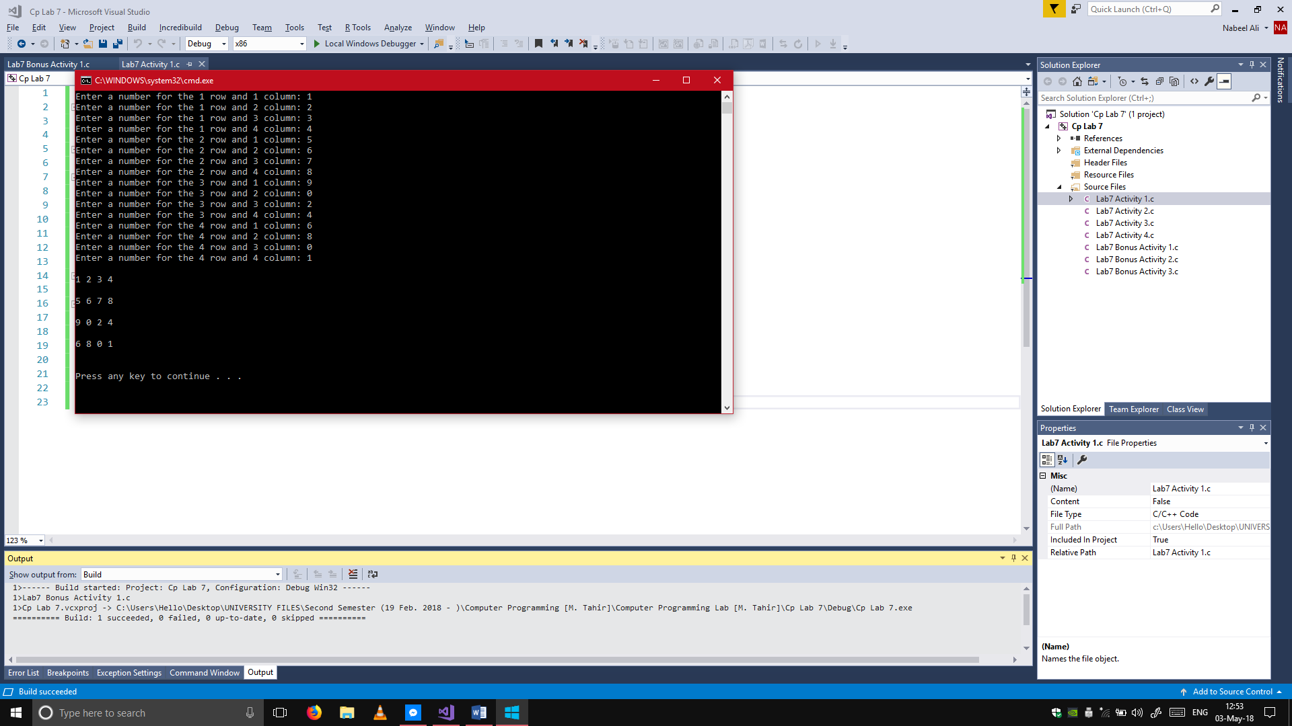

## Activity 2:

#include <stdio.h>

main()

{

int matrix1[3][3], matrix2[3][3], sum[3][3];

for (int i = 0; i < 3; i++)

{

for (int j = 0; j < 3; j++)

{

printf("Enter a number for the %d row and %d column: ", i + 1, j + 1);

scanf("%d", &matrix1[i][j]);

}

}

for (int a = 0; a < 3; a++)

{

for (int b = 0; b < 3; b++)

{

printf("Enter a number for the %d row and %d column: ", a + 1, b + 1);

scanf("%d", &matrix2[a][b]);

}

}

for (int x = 0; x < 3; x++)

{

for (int y = 0; y < 3; y++)

{

sum[x][y] = matrix1[x][y] + matrix2[x][y];

}

}

printf("The resulting matrix is: \n");

for (int m = 0; m < 3; m++)

{

for (int n = 0; n < 3; n++)

{

printf("%d ", sum[m][n]);

}

printf("\n");

}

}

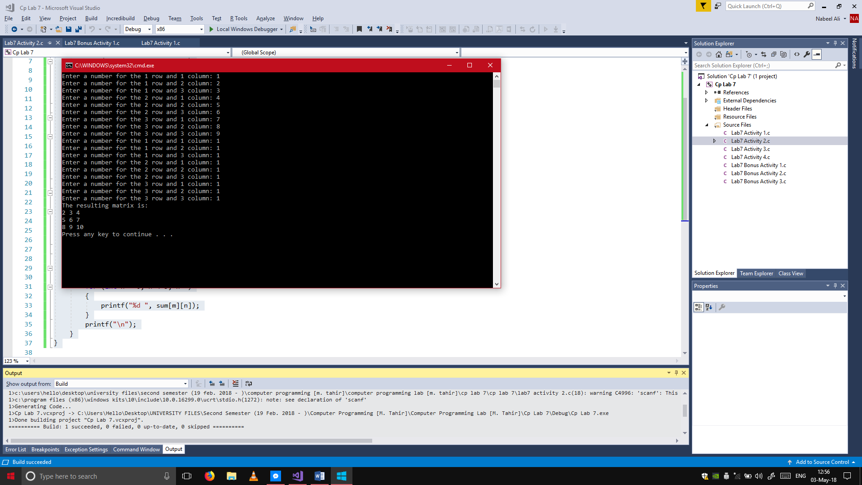

## Activity 3:

#include <stdio.h>

Transpose(int matrix[3][3], int transpose[3][3]);

main()

{

int matrix[3][3], transpose[3][3];

for (int i = 0; i < 3; i++)

{

for (int j = 0; j < 3; j++)

{

printf("Enter a number for the %d row and %d column: ", i + 1, j + 1);

scanf("%d", &matrix[i][j]);

}

}

Transpose(matrix, transpose);

for (int x = 0; x < 3; x++)

{

for (int y = 0; y < 3; y++)

{

printf("%d ", transpose[x][y]);

}

printf("\n");

}

}

Transpose(int matrix[3][3], int transpose[3][3])

{

for (int i = 0; i < 3; i++)

{

for (int j = 0; j < 3; j++)

{

transpose[j][i] = matrix[i][j];

}

}

}

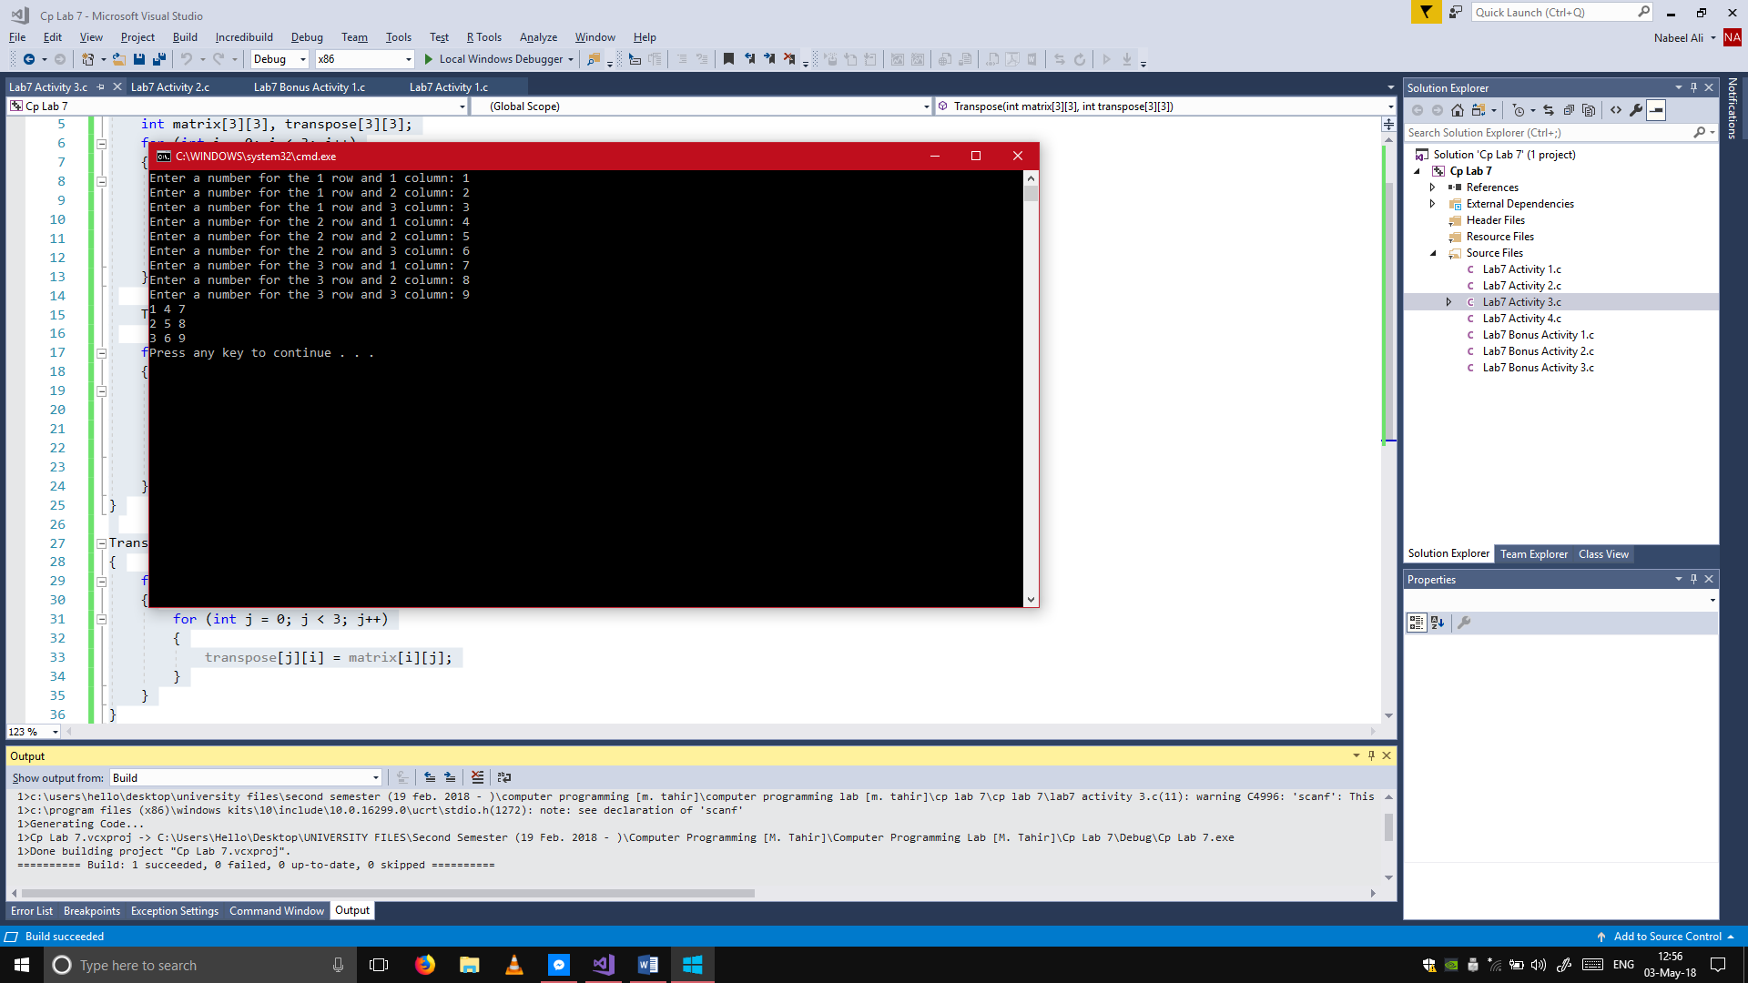

## Activity 4:

#include <stdio.h>

main()

{

int matrix1[2][2], matrix2[2][2], sum = 0, result[2][2];

for (int i = 0; i < 2; i++)

{

for (int j = 0; j < 2; j++)

{

printf("Enter the %d row and %d column in matrix 1: ", i + 1, j + 1);

scanf("%d", &matrix1[i][j]);

}

}

for (int k = 0; k < 2; k++)

{

for (int l = 0; l < 2; l++)

{

printf("Enter the %d row and %d column in matrix 1: ", k + 1, l + 1);

scanf("%d", &matrix2[k][l]);

}

}

for (int x = 0; x < 2; x++)

{

for (int y = 0; y < 2; y++)

{

sum = 0;

for (int z = 0; z < 2; z++)

{

sum = sum + matrix1[x][z] * matrix2[z][y];

}

result[x][y] = sum;

}

}

for (int m = 0; m < 2; m++)

{

for (int n = 0; n < 2; n++)

{

printf("%d ", result[m][n]);

}

printf("\n");

}

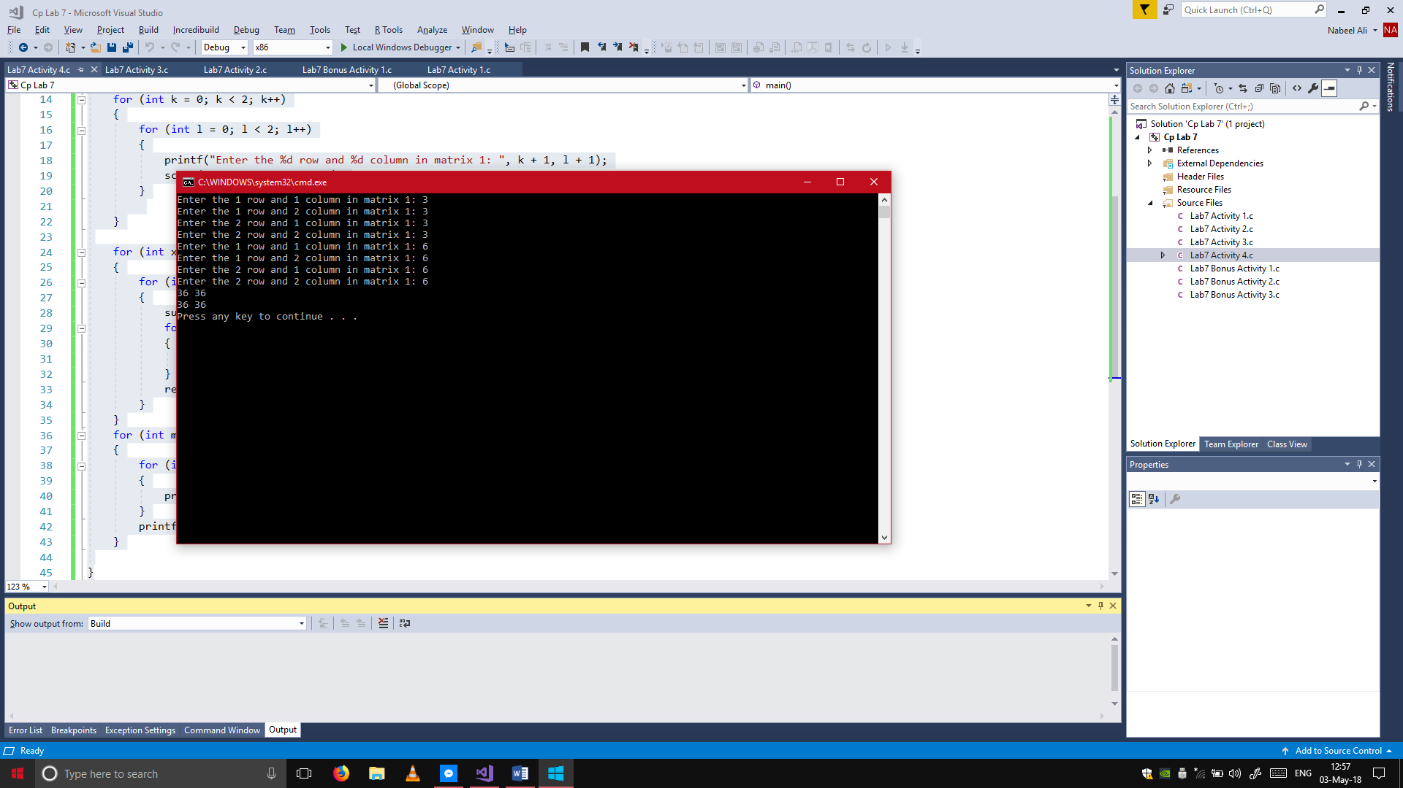}

## Bonus Activity 1:

#include <stdio.h>

main()

{

int matrix[3][3], check = 1;

for (int i = 0; i < 3; i++)

{

for (int j = 0; j < 3; j++)

{

printf("Enter a number for the %d row and %d column: ", i + 1, j + 1);

scanf("%d", &matrix[i][j]);

}

}

for (int k = 0; k < 3; k++)

{

for (int l = 0; l < 3; l++)

{

if (k == l)

{

if (matrix[k][l] == 0)

{

check = 0;

}

}

else if (k < l)

{

if (matrix[k][l] != 0)

{

check = 0;

}

}

else if (k > l)

{

if (matrix[k][l] == 0)

{

check = 0;

}

}

}

}

if (check == 0)

{

printf("The matrix is NOT a lower triangular matrix.\n");

}

else

{

printf("The matrix is a lower triangular matrix.\n");

}

}

## Bonus Activity 2:

#include <stdio.h>

main()

{

int matrix[3][3], check = 1;

for (int i = 0; i < 3; i++)

{

for (int j = 0; j < 3; j++)

{

printf("Enter a number for the %d row and %d column: ", i + 1, j + 1);

scanf("%d", &matrix[i][j]);

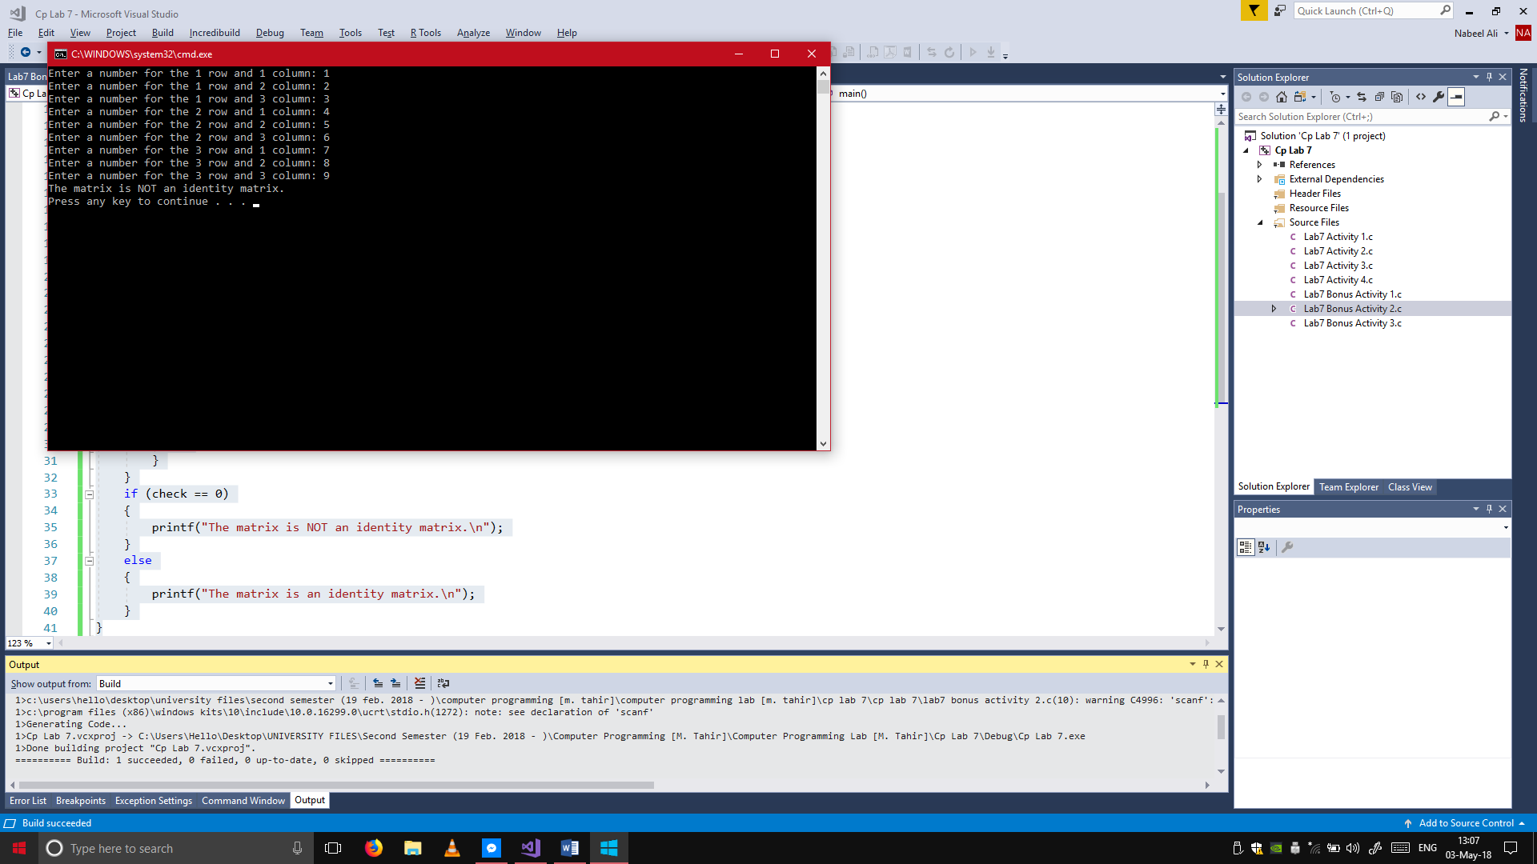 }

}

for (int k = 0; k < 3; k++)

{

for (int l = 0; l < 3; l++)

{

if (k == l)

{

if (matrix[k][l] != 1)

{

check = 0;

}

}

else

{

if (matrix[k][l] != 0)

{

check = 0;

}

}

}

}

if (check == 0)

{

printf("The matrix is NOT an identity matrix.\n");

}

else

{

printf("The matrix is an identity matrix.\n");

}

}

## Bonus Activity 3:

#include <stdio.h>

#include <string.h>

main()

{

char names[10][50];

for (int i = 0; i < 2; i++)

{

printf("Enter a name: ");

gets(names[i]);

}

for (int j = 0; j < 2; j++)

{

puts(names[j]);

}

}